1
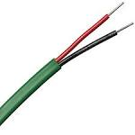

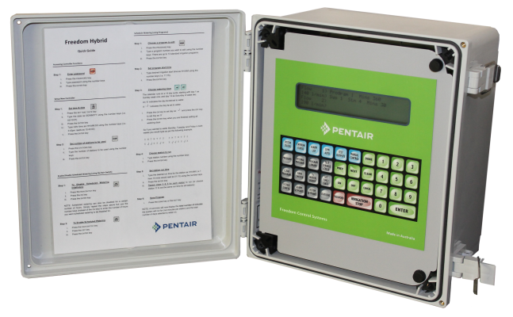
Aquamonix TWiN Controller
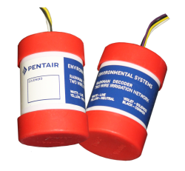
The Aquamonix TWiN Controller (Two Wire Irrigation
Network) is a versatile decoder based control system that utilizes a two wire path and can be stand alone or networked to the Aquamonix Micro Central Control System.

Standard Features
Flexi Programs  15 | Fixed Programs  6 | Max Run Time  100hrs
Start Times  6 | Max Outputs  96 | Max Inputs  40
Power Options | Ouput Options | Options
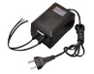  Mains | 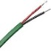  Two Wire | 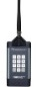  Site Remote
Available Communications
Direct Connect | 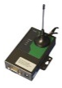  Cellular Modem | SS Radio
Decoder Options
1-2-4  Station Outputs | LPU  Inbuilt Protection | Direct Bury
Standard Outputs
Valves  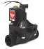 | 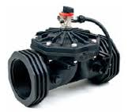  Master Valve | 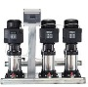  Pump/Engine  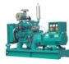
Standard Inputs
Water Meters | 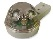  Rain Gauge | 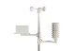  Weather Stn
Soil Moisture | Pressure  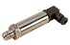 | 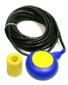  Level
Mounting Options
Wall Mount  IP66 | Panel Mount  IP22 | Project Pack  IP66
The Aquamonix TWiN Controller allows for a range of power input options, so that larger transformers can be used to extend the maximum length of cable runs.

The Aquamonix TWiN also allows for multiple ouput methods, being able to support local direct connect ion to valves pump start or master valves, as well as reading flow meters, rain switches and other devoces without the need for additional decoders.

The Aquamonix TWiN Controller can be supplied in several easy to specify formats, and can also be supplied in pre-built, pre-tested Project Packs.

The large daylight readable screen, and large direct access buttons, make the Aquamonix easy to used even for the most technology shy operator.

The Aquamonix TWiN is suitable for almost any application and is typically used for,

- Municipal Park Irrigation
Aquamonix Controllers are proudly Australian made!
- Sportsfield Irrigation
- Golf Course Irrigation
- Landscape Irrigation
- Vineyard Irrigation
- Greenhouse Irrigation
- Agricultural Irrigation
- Dust suppression Systems

Whatever your application there is a Aquamonix Control Solution to suit your requirments.

Consult the Aquamonix Product Guide for standard formats, special builds are available on request.

