10
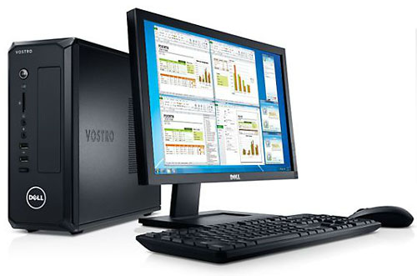

Aquamonix Master Central Infinity
The Aquamonix Master Central System is a powerful PC Based Management System that provides advanced programming and management, equipment control, compliance and cost reporting and input based scheduling.

Matser Central Infinity
Field Controllers  unlimited | Max Outputs  unlimited | Max Inputs  unlimited
Power Options |  | Options
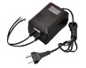  Mains/Genset | 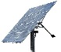  Solar/Battery | Smart Device
Hardware Required |  | Operating System
PC | Cloud | SCADA
Available Communications
Direct Connect | 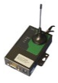  Cellular Modem | SS Radio
Ouput Options
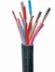  Multi Wire | 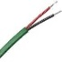  Two Wire | Radio Link
Standard Outputs
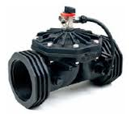  Valves | 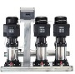  Pump Systems | 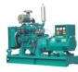  Engines
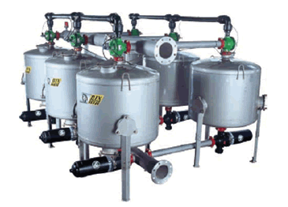  Filter Systems | 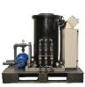  Injection Systems | 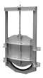  Channel Gates
Standard Inputs
Water Meters | Pressure  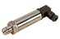 | 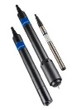  Water Quality
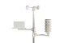  Weather Stn | Soil Moisture | 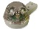  Rain Switch
The Aquamonix Master Central is a highly developed centralized control platform that networks to the Aquamonix range of controllers such as,
- Aquamonix TWiN Controller
- Aquamonix Hybrid Controller
- Aquamonix APIO Module
- Aquamonix RiC Module
- Aquamonix Web Logger

The Aquamonix Master Central has a suite of versatile programming features, and is able to input data from a range of devices, and use this information to provide complex scheduling for many applications.

The Aquamonix Master Central is pre-configured with the following program sets, and can be configured to run specific prorams on request,
- 15 x User Definable Irrigation Programs
Aquamonix
Micro Central runs best on Windows based PC’s
- ET Based Scheduling
- Soil Manager
- Looping Program
- Frost Protection Program
- Heat Stress Program
- Fertiliser Injection Program
- Filter Flush Program
- Tank Fill Program
- Diagnostic Program

The Aquamonix Master Central is pre-configured to integrate data and generate reports from the following sensor arrays, and can be utilised for billing and compliance reporting in a range of applications.
- Volume Reporting
- KWH Metering
- Compliance Reporting
- Event & Alarm Logs

Whatever your application there is a Aquamonix Control Solution to suit your requirments.

Consult the Aquamonix Product Guide for standard formats, special builds are available on request.

