Hybrid Control Module
1
TECHNICAL
SPECIFICATIONS
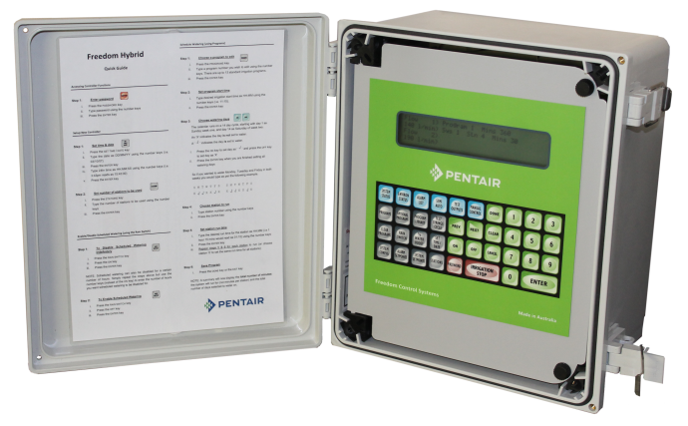
The Hybrid Control Module is the newest addition to our growing range of Innovative Control Systems.

The Hybrid Control Module is the base of a range of intelligent controllers built on the same rugged and versatile technology that has made our Controllers the first choice of professional irrigation managers for 20 years, the Hybrid gives a highly functional Control System at a low cost.

The Hybrid Control Module can operate as a standalone Control System or can be configured as a networkable RTU with the addition of a simple plug in Communications Pack.

The Hybrid controller has advanced programming features, onboard diagnostic tools and allows for multiple fixed sensor inputs such as rain switch, pulse flow meter, pressure switch, level switch or soil moisture sensors.

A series of blind alarm inputs can also be used to pause an operating program once triggered, these can be connected to a variety of switching devices and other control panel outputs.

The Hybrid Control Module can be configured to work with the TWiN Decoder System and the RiC Solar Powered Wireless System, and also allows for various power input options, allowing for mains, DC or Solar DC multi-wire systems……, whatever the application there is a Hybrid Solution to fit your needs!

Typical Applications
- Municipal Park Irrigation
- Sports field Irrigation
- Golf Course Irrigation
- Landscape Irrigation
- Vineyard Irrigation
- Greenhouse Irrigation
- Agricultural Irrigation
- Remote Systems
- Starts Pumps
- Reads Pulse Meters
- Reads Rain Switch
- Reads Soil Moisture
- Reads Level/Depth Switch
Hybrid Features
- Standalone or RTU
- SCADA Compatible
- Solar, DC or AC Powered
- 15 Standard Programs
- 6 Specialized Programs
- Up to 96 Zones
- Multi-Level Password on Keyboard
- Large Direct Access Keypad
- Large 4 line Daylight Screen
- Two Wire Option
- Syringe Cycle
- Filter Flush
- Fertigation
- IP67 Enclosure as standard
- Australian Made

Electrical Specifications
Power Supply Options | 24VAC 50/60Hz  24VDC  12VDC |  | Fuse | 3.15A on board fuse for power supply and relay output voltage
Outputs | Relay Outputs N/O  30VAC/VDC 3A Max  3000VAC Isolation  10ms contact settling time  Current sensing on relay bank |  | Digital Inputs | Close contact optically isolated inputs  4VDC or up to 12mA (25mW) per input  1600VDC isolation on the supply  Pulse inputs:  0.1 to 50 pulses per second  10ms minimum pulse width  Frequency inputs:  1 to 450Hz
Communications | 1 x RS485 Expansion Port  1 x RS232 CCS Port  2 x Configurable RS485/232 Ports
Operating Conditions | Temperature 0° to 75°C  Humidity 5 to 95% non condensating |  | Analog Inputs | 4-20mA optically isolated inputs  Loop or self-powered sensors  24VDC loop supply  1600VDC isolation on the supply

Networking Options
Network Protocols | Open Protocol  DNP3  MODbus |  | Cellular Connect Options | 3G/GSM M2M Modem  3G/GSM Gateway Modem
Central Control Capability | RAINman Central Control  SCADA Based Systems |  | Wireless Connect Options | VHF Radio  UHF Radio
Direct Connect Options | RS485  Fibre Optic |  | Other Options | Sat Link Modem/Router

A large range of third party communications equipment is able to be integrated with the Hybrid Control Module, check the design guide for specifications.

Control Output Options
AC Multi Wire | 19-32VAC  Max 96 Stations |  | TWiN Decoder Based Two Wire | TWiN Decoders  TWiNcoil Combo Solenoid/Decoder  Max 200 Stations
DC Multi Wire | 9-12VDC Latching, 150ms  Max 96 Stations |  | RiC Remote Wireless  Control | 9-12VDC Latching, 150ms  Max 96 Stations

Any mix of Control output methods can operate on a single Hybrid Control Module. TWiN System requires the addition of a TWiN Driver Module and Power Supply. RiC System requires the addition of a RiC Base and RiC Satellite Modules.

