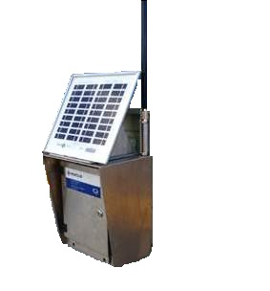
2

Aquamonix RiC Module

The Aquamonix RiC Module (Remote Irrigation Controller) is a reliable solar powered, wireless system and can be used as an extension to a Aquamonix Hybrid Controller or networked to the Aquamonix Micro Central Control System.

The Aquamonix RiC Module is a networked satellite module that uses solar power to operate DC Latching outputs, that can be used to operate valves, or relays to start/stop pumps and engines.

Standard Features
Communications  Radio Link | Latching Outputs  8 | Pulse Inputs  2
Power Options
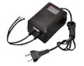  Mains/Genset | 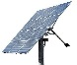  Solar/Battery | Solar Regulator  Onboard
Standard Outputs
Valves  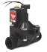 | 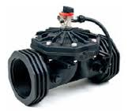  Master Valve | 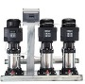  Pump/Engine  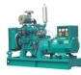
Standard Inputs
Water Meters | 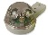  Rain Gauge | Soil Moisture
Maximum number of RiC units
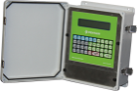 | Networked to Stand Alone Aquamonix Hybrid | 12  per Controller
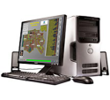 | Networked to Aquamonix Micro Central Control | 120  per Central
Mounting Options
Pole Mount  IP66 | Panel Mount  IP22 | Project Pack  IP66
The Aquamonix RiC uses a spread spectrum, licence free radio bandwidth, providing a stable communications network. Each RiC can be configured as a Base, Repeater or Satellite unit allowing long distances to be covered and mulitple network clusters established.

Full programming and scheduling is a function of the base controller with the RiC serving as a wireless extension.

The RiC Can also be used as a wireless node to relay data back to the base controller via onboard serial ports.

The Aquamonix RiC Module is suitable for many applications and is typically used for,

- Municipal Park Irrigation
Aquamonix Controllers are proudly Australian made!
- Golf Course Irrigation
- Landscape Irrigation
- Vineyard Irrigation
- Traffic Islands
- Agricultural Irrigation
- Dust suppression Systems
- Pump Start
- Engine Control
- Tank Fill

Whatever your application there is a Aquamonix Control Solution to suit your requirments.

Consult the Aquamonix Product Guide for standard formats, special builds are available on request.

