3

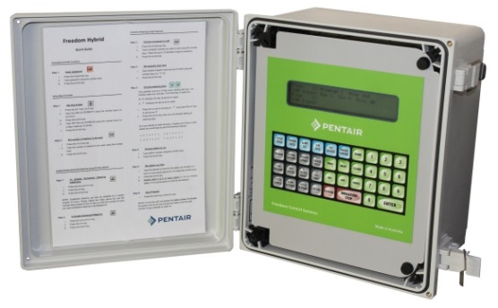
Aquamonix Hybrid Controller

The Aquamonix Hybrid Controller is a versatile controller that allows for multiple control methods and can be stand alone or networked to the Aquamonix Micro Central Control System.

Standard Features
Flexi Programs  15 | Fixed Programs  6 | Max Run Time  100hrs
Start Times  6 | Max Outputs  96 | Max Inputs  40
Power Options |  | Options
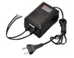  Mains/Genset | 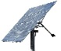  Solar/Battery | 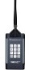  Site Remote
Available Communications
Direct Connect | 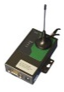  Cellular Modem | SS Radio
Ouput Options
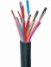  Multi Wire | 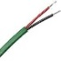  Two Wire | Radio Link
Standard Outputs
Valves  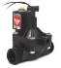 | 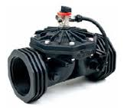  Master Valve | 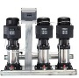  Pump/Engine  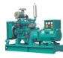
Standard Inputs
Water Meters | 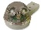  Rain Gauge | 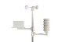  Weather Stn
Soil Moisture | Pressure  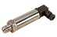 | 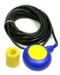  Level
Mounting Options
Wall Mount  IP66 | Panel Mount  IP22 | Project Pack  IP66
The Aquamonix Hybrid Controller operates with a range of power inputs, and is suitable for mains AC powered, AC or DC Powered Generators or Solar DC Powered sites.

The Aquamonix Hybrid also allows for multiple ouput methods, being able to support AC or DC Multipath, AC Two Wire and DC Radio Link to field valves, combinations of these can be supported on one controller.

The AquamonixHybrid Controller can be supplied in several easy to specify formats, and can also be supplied in pre-built, pre-tested Project Packs.

The large daylight readable screen, and large direct access buttons, make the easy to use even for the most technology shy operator.

The Pentiar Hybrid is suitable for almost any application and is typically used for,

- Municipal Park Irrigation
- Sportsfield Irrigation
Aquamonix Controllers are proudly Australian made!
- Golf Course Irrigation
- Landscape Irrigation
- Vineyard Irrigation
- Greenhouse Irrigation
- Agricultural Irrigation
- Dust suppression Systems

Whatever you application there is a Aquamonix Control Solution to suit your requirments.

Consult the Product Guide for standard formats, special builds are available on request.

