4

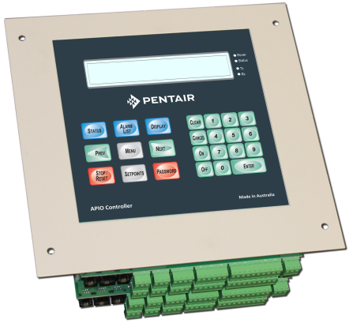
Aquamonix APIO Control Module
The Aquamonix APIO Control Module is a versatile equipment controller that allows for multiple control methods and can be stand alone or networked to the Aquamonix Micro Central Control System.

The APIO Control Module allows for a range of power options, and is suitable for mains AC powered, AC or DC Powered Generators or Solar DC Powered sites.
Standard Features
Comms Ports  4 | Max Outputs  96 | Max Inputs  40
Power Options |  | Options
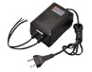  Mains/Genset | Solar/Battery | 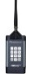  Site Remote
Communications Protocols |  | Operating System
Modbus | DNP3 | SCADA
Available Communications
Direct Connect | 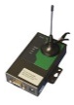  Cellular Modem | SS Radio
Ouput Options
Multi Wire | 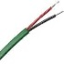  Two Wire | Radio Link
Standard Outputs
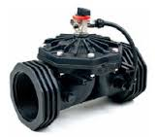  Valves | 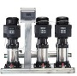  Pump Systems | 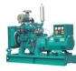  Engines
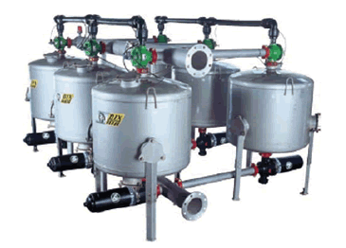  Filter Systems | 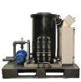  Injection Systems | 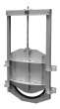  Channel Gates
Standard Inputs
Water Meters | Pressure  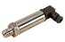 | 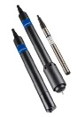  Water Qulaity
Mounting Options
Wall Mount  IP66 | Panel Mount  IP22 | Project Pack  IP66

The APIO allows for easy adaptability to provide a wide range of engineering solutions to both control and monitoring applications, and has a powerful range of programming capability and is capable of executing commands from its programmed memory, or those issued by a remote master, and returning a variety of input data such as current I/O status, logged analogue values, pulse counts etc..

The APIO Controller can be supplied in several easy to specify formats, and can also be supplied in pre-built, pre-tested Project Packs.

The large daylight readable screen, and large direct access buttons, make the Freedom easy to used even for themost technology shy operator.

The APIO is suitable for almost any application and is typically used for,

- Energy Management Systems
Aquamonix Controllers are proudly Australian made!
- Aquaculture Systems
- Channel Irrigation Systems
- Remote Pumping Systems
- Injection & Filtration Systems
- Pump Control
- Engine Control
- Gate Control

Whatever your application there is a Aquamonix Control Solution to suit your requirments.

Consult the Control Solutions Product Guide for standard formats, special builds are available on request.

